Lego Strategic Plan
Name of the institution
Name of the student
Date

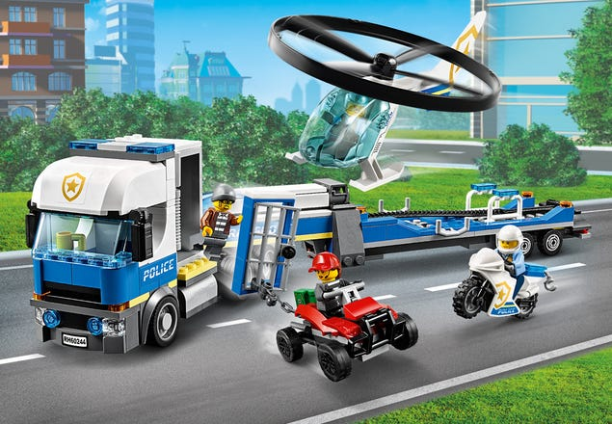
Introduction to the organization
The history of LEGO group dates back to 1932 when a small workshop was put in place to make wooden toys. The company derives its name from Danish words meaning play well
It is most famous for its LEGO bricks which was introduced in 1958 and named twice as the toy of the century. It has advanced from wooden to plastic toys and currently it has web based games and videos for kids.
The company is currently managed by 6 board of directors’ members who have a wide industry experience and a group of 9 executive members.
With its web based games, it is currently operating internationally but restricts some games access to certain regions. This is because they have modified their product to match the needs of their target group.
Identification of industry and competitors
LEGO Group operates in the entertainment industry where they have their major brand being toy and games making plastics toys by use of the interlocking brick toys technology and the online gaming where it has created a real market brand with support services through their amusement parks which are under the recreational section of entertainment and retail stores at numerous places which act as a marketing tool for LEGO to meet its clients. The company has done well in the market share having out done previous competitors like Coko Toy co., and having given real challenge to its close competitors like Tyco toys, Mega Bloks and Best-lock. The company however failed in the attempt to secure its patent right to an extension against Mega Blocks and Best-lock which could have created a kind of monopoly and could have enhanced the more sales on Lego brand. Currently the company faces great competition in the market from firms like Mattel, Hasbro, Tricae and Zapf creation which are operating almost on the same scale but Lego has been managing the competition in the market.

Analysis of organization – Measurement and control system III
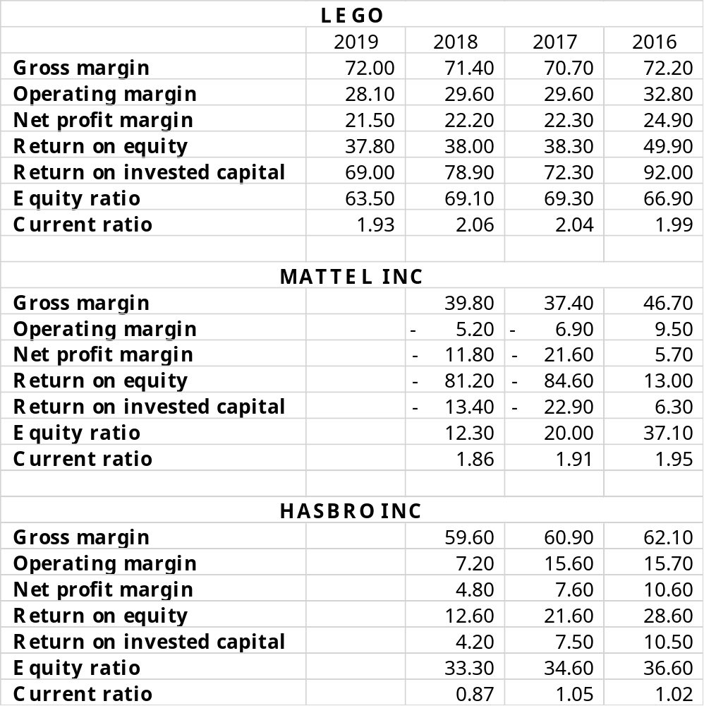
Analysis of organization
The company develops various strategies to enable it remain operational and competitive. Among them is the tax strategy which is developed by the board and it is in place to ensure that the company remains compliant and up to date about the international business environment. Being compliant ensures that it does not face litigations in its foreign operations which could be disastrous in a way. The company also has dividend strategies in place to ensure that all available liquidity is distributed to shareholders but being keen on its operational capacity. The company is forward looking in its endeavor to ensure long term stability. The company is investing in online markets to ensure that customers purchase their games and toys not only in their physical stores but also in the online stores. They have also advanced in their web based games which are very cost effective in terms of logistics and can be accessed everywhere with minimal limitations. This ensures that their products are available in a timely manner and at the optimal price. They also ensure security by restricting game access in some regions. The company has also invested in new geographies especially china which is a very strategic market for the toys. This keeps the company above its competitors in terms of availability of their products, cost wise and in terms of gross revenue. This has made the company demand a bigger market share and better operating profits than its competitors.
Based on the above strategies the company is expected to outperform the competitors in terms of market share and profitability. Its adoption of online stores will drive more sales while cutting down on some costs like the distribution and logistics costs. Web based games are also easily accessible and this will also drive more sales and advance on the brand visibility. The company is expected to further cut down on its operating expenses which will improve on profitability availing more cash flow for research and development and also a better return to its shareholders. This will make the company more appealing for strategic investors who may inject more funds in the future to bring a competitive advantage.
Strengths
- Lower cost of production as shown by a high gross profit margin
- Sufficient liquidity as shown by the current ratio
- Technology advancement
- Online stores
- Experienced and diverse board of directors
Weaknesses
- Failure in making universal web based games – Leading to some restrictions limiting sales.
- Focusing on a single industry - This limits risk cushioning offered by portfolios.
Opportunities
- Growing markets
- Online games potential
- Parents becoming more enlightened on usefulness of toys in learning
- Games and toys for adults
- Educative toys which may be more preferred by parents
Threats
- Growing competition
- Effect of cybercrime to their web based games
- Fast changing environments which may make games obsolete within a short period of time
- Globalization which speeds up destructive effect on businesses in case of a crisis in one part of the world.
Conclusion and future of organization
- Mattel 19%
- Hasbro 15%
- Lego 9%
International Engagement
LEGO Group is already engaged in international activities as it operates in continents beyond its home continent. It has offices in United States, England, Germany, Netherlands, China, Australia, Canada, Spain, Russia and Japan.
Q1. Is your company varying its product or service to adapt to differences in countries? Is the marketing approach different among the nations involved? Should it be?
The company operates through licensing stores. The stores are licensed and then operated by third parties. As a result of this inventory in the stores may vary together with the pricing and promotional strategies. Online orders can however be placed through their group website. The use of licensed stores gives some variation on the company marketing strategy as different prices and promotions may be used by different stores not controlled by the group. The company thus indirectly varies its inventory and pricing as marketing strategy. Its online games are also restricted in some countries.
Different people with different backgrounds and socio-cultural characteristics would prefer different types of commodities and this makes variations in LEGO’s product across different countries logical.
Q2. Is your firm working internationally to access larger markets? To gain low-cost input factors? To develop new competencies? Is its approach in all three areas appropriate?
The company is working internationally primarily to access larger markets. In their financial reports the company has specifically indicated China as an emerging market for its products supporting the notion that their main aim of going internationally is to gain more market for its product. There isn’t any information available to support the idea that they may be going internationally to gain low cost input factors.
Q3. Which of the four global strategies is the firm using? Is this the best strategy for it to use? Why or why not?
The company has adopted the global strategies indirectly using the licensed stores operated by third parties. This means that they have localized their products as the stores will purchase from the company what is proven to be fit for the local area. They have also developed a good marketing plan in having offices across the countries while at the same time licensing stores. This ensures that the working of the stores is well synchronized with the operations of the company.

